



**BTP Report**

**on**

**EMOTION AI**

**Submitted by:**

**Sahil Agrawal 20CS3054**

**Submitted to:**

**Dr. Rahul Kumar**

**Assistant Professor**

**Department of Computer Science and Engineering**

**EMOTION AI**

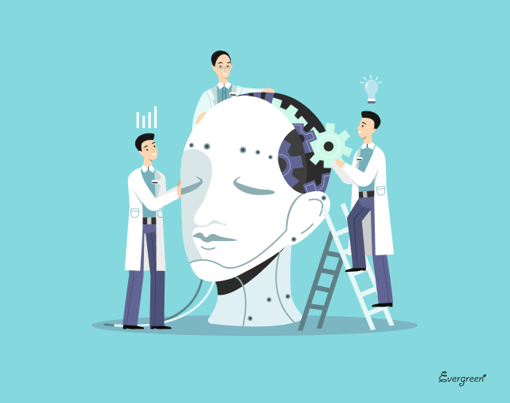

**Abstract**

The emotional intelligence has emerged as an important area of research in artificial intelligence covering wide range of real-life domains. A significant contribution has also been made to bring new insights in the field of emotional intelligence and intelligent software agents. Learning agents and educational activities are very attractive for incorporation of emotional aspects in artificial intelligence. Emotions have an important role in intelligent behaviour and influence the human decision-making process. An overview of the state-of-the-art in emotional intelligence research with emphasis on emotional agents has been given covering the area like Emotion detection, Emotional agents, Text emotion detection, Modelling artificial agent’s environments, Emotional intelligence and different forms of learning, Emotional agents in robotics, Emotional intelligence in decision support processes, Emotional intelligence in interactive environments, Emotional intelligence in classification and search, Emotion models. Taking the first step, the following review discuss about our work on emotion detection .

**Table of Contents**

**Chapter 1 - Introduction**

**Chapter 2 - Overview of Project**

**Chapter 3 - Specification of Project**

**Chapter 4 - Project Use Interface/Language/Tools/DBMS used in project Details**

**Chapter 5 - Results of the Project**

**Chapter 6 - Contribution Made by you to project**

**Chapter 7 - Conclusion**

1. **Introduction**

Emotion AI is a subset of artificial intelligence (the broad term for machines replicating the way humans think) that measures, understands, simulates, and reacts to human emotions. It’s also known as affective computing, or artificial emotional intelligence.

1. **Overview of Project**

Humans portray different emotions through various modalities, among which speech and image are known to contain human emotions and intentions most effectively.

Multimodal emotion recognition also faces the issue of the unavailability of sufficient labelled datasets for training.

**Steps Involved:** 1) Collecting data from databases for various Emotion.

2) Applying various feature extraction methods.

3) Applying deep learning method over the extracted features to train the prediction model.

4) Using the model to predict the emotions.

**Goal:** 1) Apply deep learning approaches to classify various emotions improving accuracy from

the current state-of-art models.

2) Build an app or web application to detect live emotions.

1. **Specification of Project**

* The data used are CK+ **[All the work related to this data done by me]** and FER2013 **[All the work related to this data done by Manish Wahale]**
* The filters used for feature extraction are HOG (Histogram of Oriented Gradients**) [Both Contributed]** and LBP (Local Binary Pattern**) [Both Contributed]**
* Used deep CNN model to train over the extracted features.

The Project Pipeline looks like the figure below.



The LBP model trained over the extracted features of FER2013 dataset is used to develop an OpenCV app to detect real-time facial emotions. **[Both Contributed]**

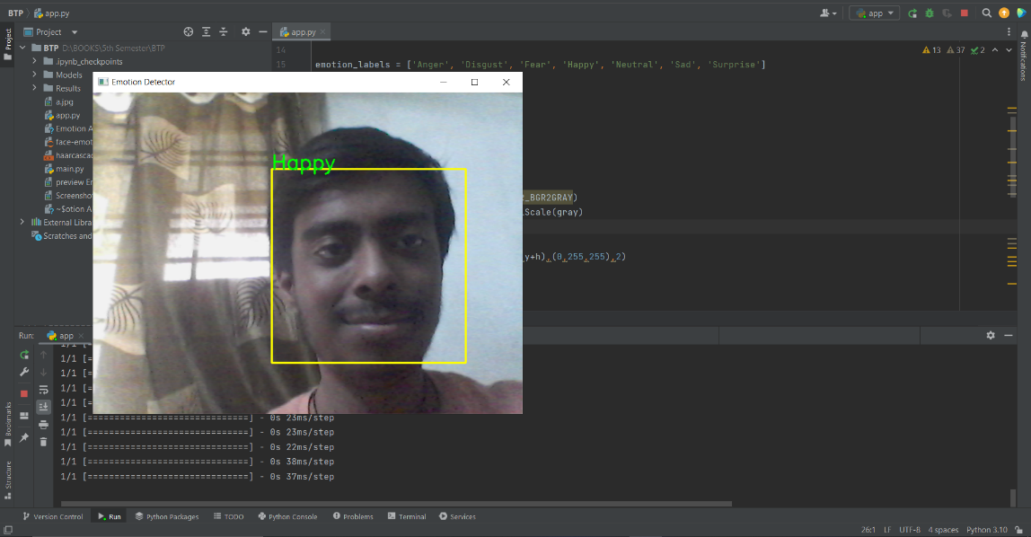

1. **Project Use Interface/Language/Tools/DBMS used in project Details**

**Language:** Python

**Tools:** Tensorflow, SkImage, Numpy, Matplotlib, OpenCV2.

**Database/Datasets :** [FER2013](https://paperswithcode.com/dataset/fer2013), [CK+](https://paperswithcode.com/dataset/ck#:~:text=CK%2B%20(Extended%20Cohn%2DKanade%20dataset)&text=sadness%2C%20and%20surprise.-,The%20CK%2B%20database%20is%20widely%20regarded%20as%20the%20most%20extensively,of%20facial%20expression%20classification%20methods.)

**Project Use:** There are many applications of Emotion AI. Our Emotion Detection model can be used as a attention check AI in schools to track emotion of students to judge student’s attention in classroom which can also prove to be a feedback tool for a class.

Another future application is to track a driver’s drowsiness and automatically stopping vehicles slowly to safety. There’s common cause of late night accidents due to drowsy heavy vehicle drivers which can be minimized by this AI.

1. **Results of Project**

Below shows Confusion matrix, Precision-Recall curve and ROC-AUC curve of various models.

**HOG model on FER2013**

Accuracy Score: 0.5125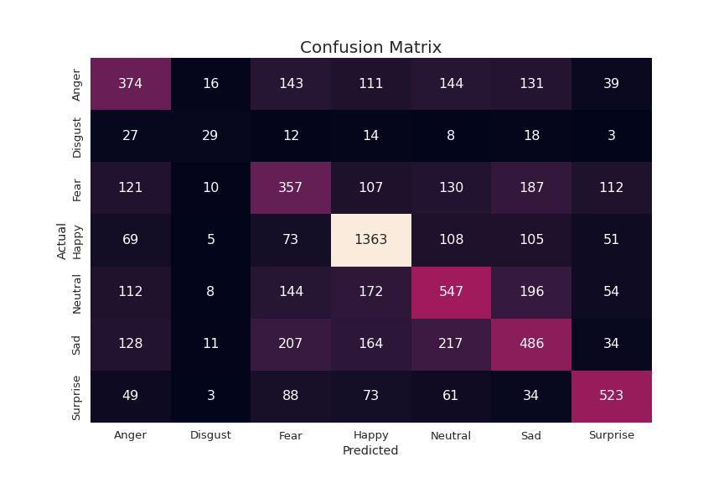

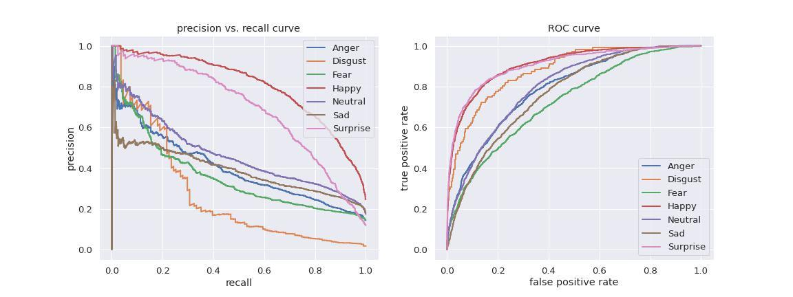

**HOG model on CK+**

Accuracy Score: 0.9798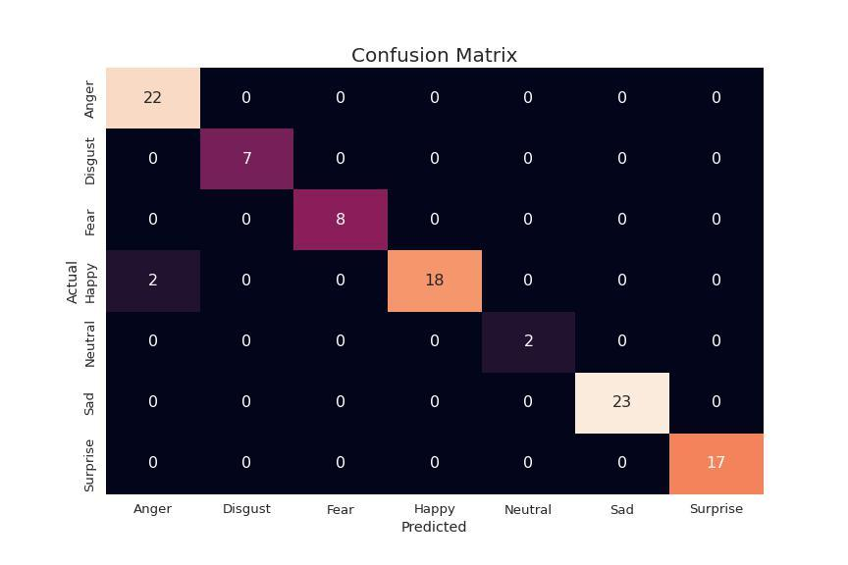

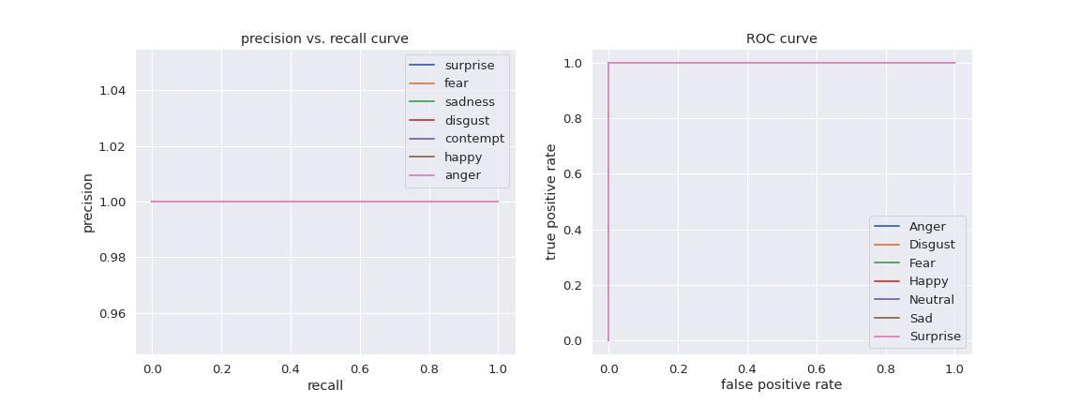

**LBP model on FER**

Accuracy Score: 0.5025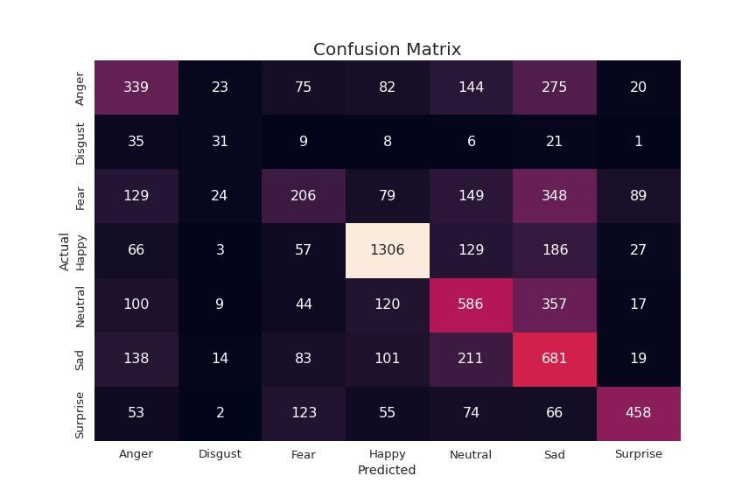

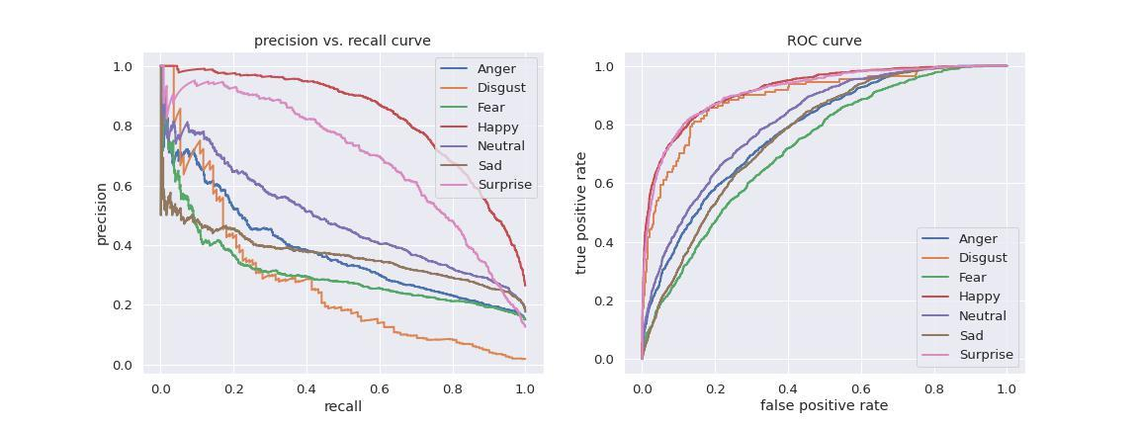

**LBP model on CK+**

Accuracy Score: 0.9899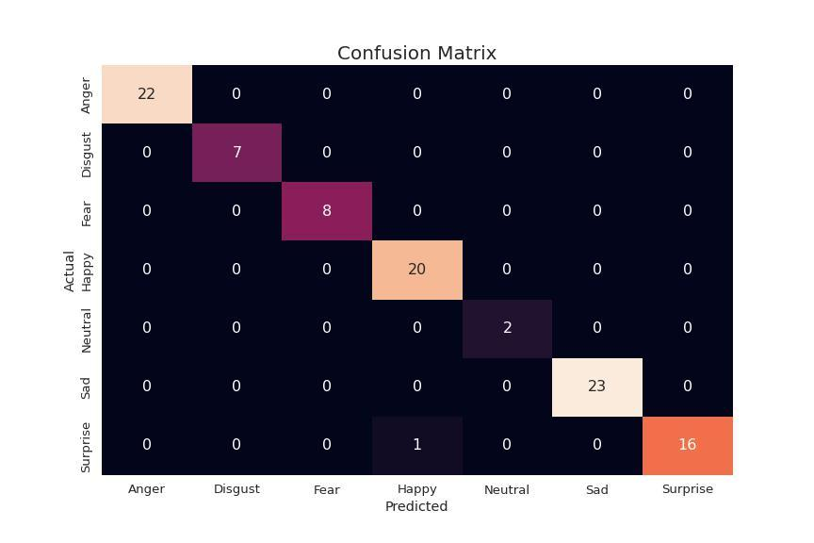

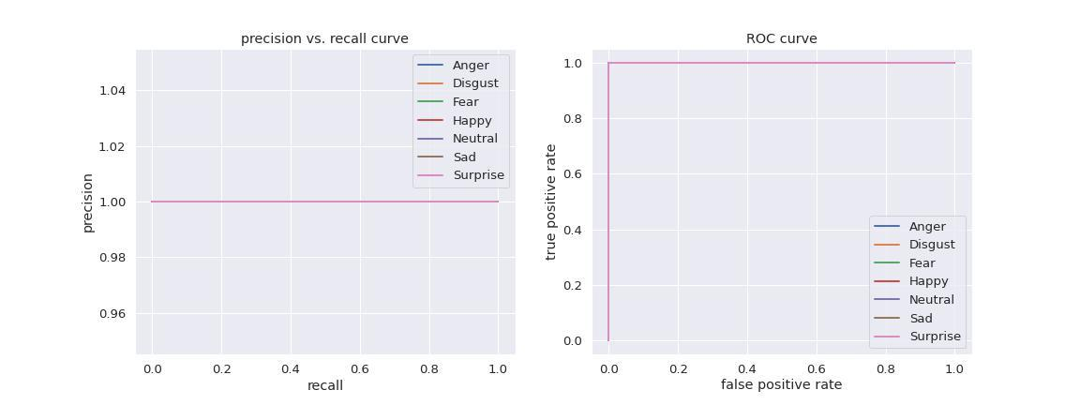

1. **Contribution made to the project**

Extracted HOG and LBP features from the FER2013 images and build a deep CNN model for prediction.

Developed OpenCV app for real-time facial expression detection.

1. **Conclusion**

Emotion AI has a much greater application in the future which would change the way every one lives and bring much more optimization in our work. Through this project we just kick started the basic building block or foundation of emotion AI through emotion detection. The deep learning methodologies have great capabilities which helped us to make our model well tuned. We got an F1 accuracy score of 99% with LBP filter extraction and 98% with HOG feature extraction on CK+ data which is more clean than FER2013 with accuracy of 51% with HOG feature extraction and 50% with LBP feature extraction. The FER2013 generalized very well for low quality images which we then applied to our facial emotion detection app. The CK+ dataset has good quality images which helped model to better understand the features.